News Release

For Immediate Release: April 2, 2013
FreedomPACS Giving Away Complete Radiology PACS Bundle in Spring 2013 Drawing
Valued at $40,000, prize includes PACS solution with cloud offsite storage and diagnostic Web viewer
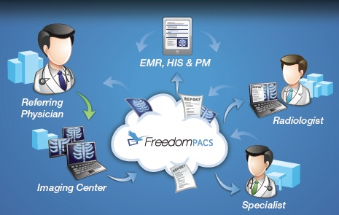
SOUTHFIELD, MICH. — FreedomPACS™ invites eligible medical facilities to enter its Spring 2013 Drawing, which runs through Saturday, April 13. Qualified participants have a chance to win a complete medical picture archiving and communication system (PACS) for their healthcare facility.

The Web-based PACS prize bundle, valued at $40,000, also includes offsite storage utilizing cloud technology and a DICOM diagnostic viewer. These cost-effective resources help medical providers access, store, retrieve and disseminate their digital images and reports safely and efficiently.

To enter, participants can complete the official entry form and official drawing rules online at http://www.freedompacs.net/pacs-drawing. Or, those attending the MASA (Medical Association of the State of Alabama) Annual Session may do so in person by visiting the FreedomPACS booth April 12 or 13 in Mobile.

No purchase is necessary to enter the drawing. Participants must be at least 18 and legitimate representatives of health facilities (under 50 beds) or medical clinics or practices (less than 20 doctors). Installation and support of the radiology PACS prize bundle are the responsibility of the winner. For more information, call 855-740-1130.

About FreedomPACS™ Radiology PACS Solutions
FreedomPACS (http://www.freedompacs.net) is a cost-effective medical PACS that provides convenient, economical access and archiving of images from multiple modalities using cloud technology. This radiology system incorporates DICOM standards and can be accessed on Windows or Mac as well as mobile platforms like iPad and Android.

FreedomPACS Cloud offers secure, HIPAA-compliant off-site storage for radiology images. Available with or without a PACS system, this affordably priced solution harnesses the protection and efficiency of the cloud. It provides instant access and can integrate with other medical, equipment or PACS systems. FreedomPACS is owned by MN Systems, headquartered in Southfield, Mich., a joint venture between a medical software development company and a group of practicing physicians.

Connect with FreedomPACS on:
Twitter: http://www.twitter.com/FreedomPACS
Facebook: http://www.facebook.com/FreedomPACS

Contact:
Sonia Coleman, Coleman Unlimited
636-861-7282, scoleman@colemanunlimited.com

###

