News Release

For Immediate Release: June 30, 2014

FreedomPACS Solves Radiology Image Access Challenges
for Michigan Outpatient Center and 500 Ordering Physicians
Premier MRI/CT Streamlines Image Access, Sharing and Storage with Secure, Cost-Effective Cloud Technology

SOUTHFIELD, MICH. — Ever since Premier MRI/CT implemented the web-based medical imaging solutions of FreedomPACS™, the multi-location outpatient center has experienced significantly improved workflow, patient care and savings.

The benefits experienced by Premier, which serves thousand of patients each year in the tri-county area near Detroit, are detailed in the latest FreedomPACS case study.

With cloud storage, ImageShare technology and on-site radiology PACS, Premier has virtually eliminated its former medical image access challenges experienced by patients and the center’s nearly 500 ordering physicians.

For example, Premier no longer has to rely on cumbersome physical records and outdated CDs to store and share X-rays, MRAs, CTs and MRIs with patients and their primary care physicians or specialists.

“With so many locations geographically, moving around physical records was problematic. It was impractical for the amount of volume we have and the number of patients we see,” explained Gary Wood, director of Premier MRI/CT.

“FreedomPACS is much easier, less frustrating to outside doctors, and more affordable than the image sharing solutions I used during my 28 years on the hospital side of radiology,” Wood said.

More specifically, FreedomPACS has helped Premier to:
- Affordably digitalize radiology studies and medical images.
- Offer secure, round-the-clock web access to ordering physicians on multiple PC and mobile platforms.
- Satisfy FDA and HIPAA patient safety and privacy criteria.
- Reduce problematic “lag time” between imaging/testing and final diagnosis and treatment.

“With FreedomPACS, we are able to operate an imaging center that has multiple sites and manage our images so that they are readily accessible, secure and backed up,” Wood shared.

“FreedomPACS also enables us to archive our images across multiple sites—efficiently, inexpensively and with quick access to images regardless of where our doctors might be located. ImageShare is a great benefit as it allows us to connect our external physicians securely so that they can see their patients’ exams,” he added.

[MORE]

Call FreedomPACS at 855-740-1130 or fill out the online form for more details or to request a demonstration of the provider’s signature medical imaging solutions.

Read the full case study: Premier MRI/CT Provides Efficient, Secure Radiology Image Sharing for 500 Physicians

- Learn how a Texas county hospital improved patient care and saved 75% with FreedomPACS.
- Discover the five best practices for utilizing mobile devices in radiology and healthcare.
- Read more FreedomPACS News.

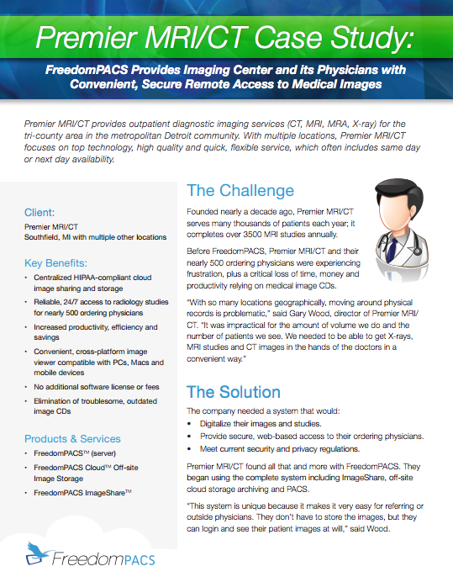

About FreedomPACS™
FreedomPACS provides efficient and economical medical imaging solutions to healthcare professionals, practices and facilities. Signature offerings include server and web-based medical PACS (picture archiving and communication system), off-site cloud storage, a cross-platform diagnostic viewer and ImageShare, enabling secure sharing of radiology studies with outside facilities.
FreedomPACS is owned by MN Systems, headquartered in Southfield, Mich., a joint venture between a medical software development company and a group of practicing physicians.

Connect with FreedomPACS on:
Twitter: https://twitter.com/FreedomPACS
Facebook: http://www.facebook.com/FreedomPACS

Contact:
Sonia Coleman, Coleman Unlimited
636-861-7282, scoleman@colemanunlimited.com

